Exercise Problems for Module 8
The exercise problems in Module 8 provide practice with analyzing simple narrative problems and design transformations. I have used Visual Paradigm for this assignment.

- Define an ERD for the following narrative. The database should track homes and owners. A home has a unique home identifier, a street address, a city, a state, a zip, a number of bedrooms, a number of bathrooms, and square feet. A home is either owner occupied or rented. An owner has a unique owner number, a Social Security number (used for government reporting requirements), a name, an optional spouse name, a profession, an optional spouse profession, and an optional spouse Social Security number. An owner can possess one or more homes. Each home has only one owner.
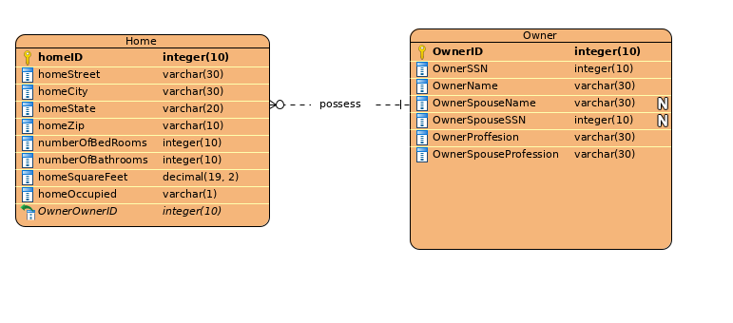

2. Refine the ERD from problem 1 by adding an agent entity type. Agents represent owners in the sale of a home. An agent can list many homes, but only one agent can list a home. An agent has a unique agent identifier, a name, an office identifier, and a phone number. When an owner agrees to list a home with an agent, a commission (percentage of the sales price) and a selling price are determined.
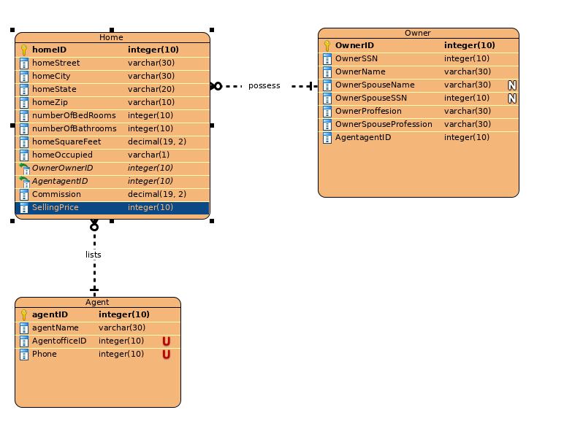

3.In the ERD from problem 2, transform the attribute, office identifier, into an entity type. Data about an office include the phone number, the manager name, and the address.

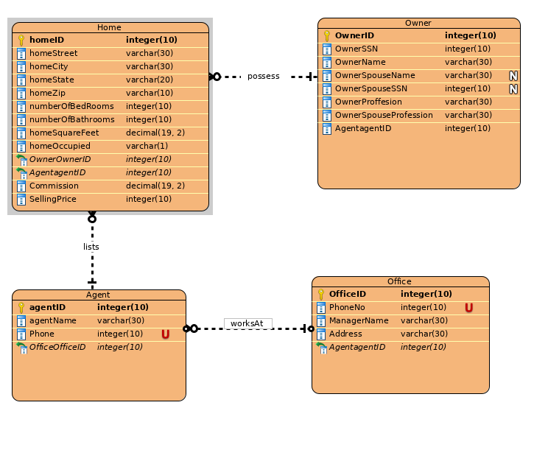

4.In the ERD from problem 3, add a buyer entity type. A buyer entity type has a unique buyer identifier, a Social Security number (used for government reporting only), a name, an address, a phone number, optional spouse attributes (name and Social Security number), and preferences for the number of bedrooms and bathrooms, and a price range. An agent can work with many buyers, but a buyer works with only one ageent.
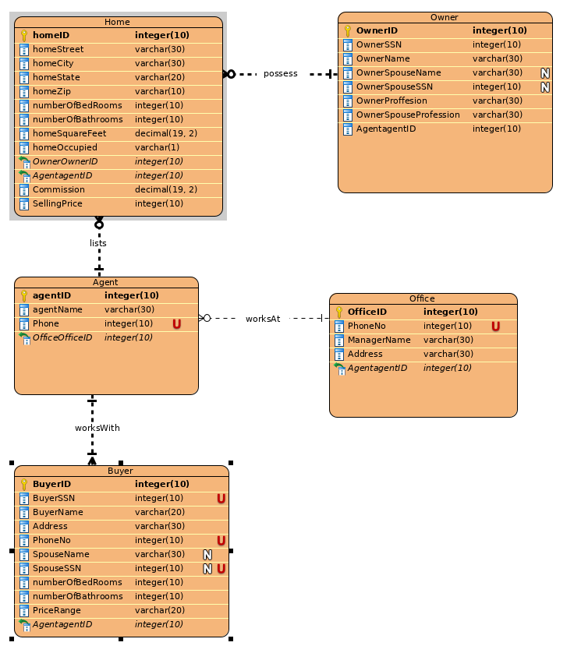

5.Revise the ERD from problem 5 by adding an offer entity type. A buyer makes an offer on a home for a specified sales price. The offer starts on the submission date and expires on the specified date. A unique offer number identifies an offer. A buyer can submit multiple offers for the same home.
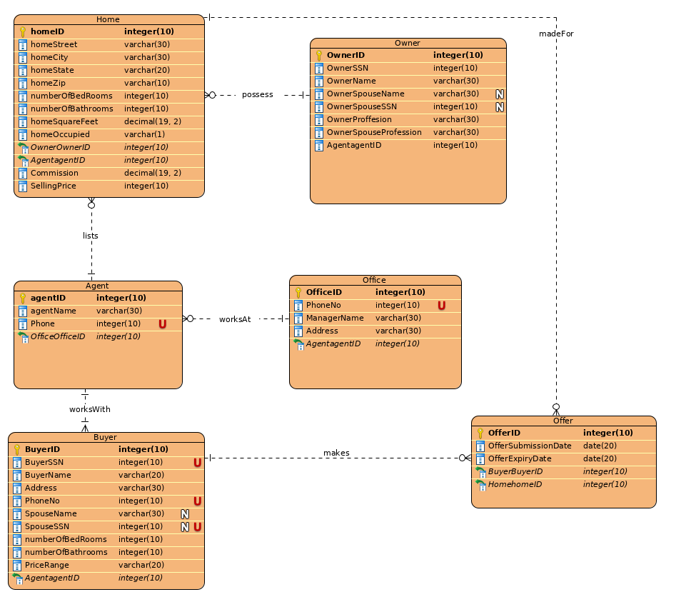

6.Design an ERD to represent a credit card statement. The statement has two parts: a heading containing the unique statement number, the account number of the credit card holder, and the statement date; and a detail section containing a list of zero or more transactions for which the balance is due. Each detail line contains a line number, a transaction date, a merchant name, and the amount of the transaction. The line number is unique within a statement.
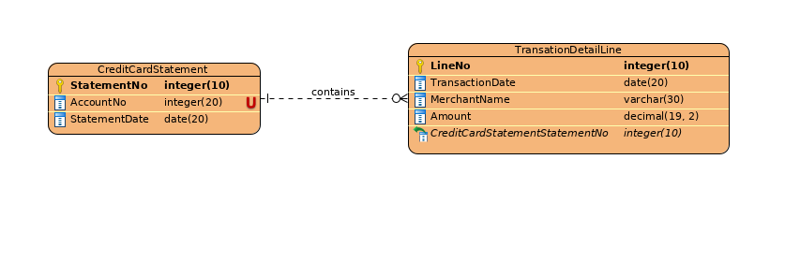

7.Modify your ERD from problem 10. Everything is the same except that each detail line contains a unique transaction number in place of the line number. Transaction numbers are unique across statements.
